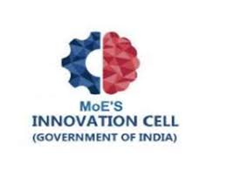
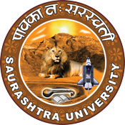
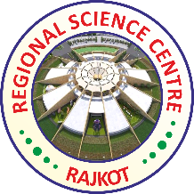
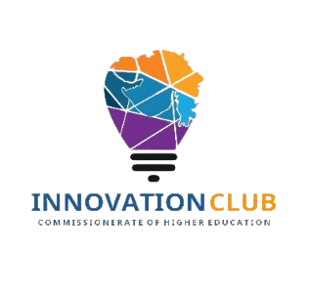

Institution's Innovation Council
Saurashtra University
An interactive visit on the latest trends in the field of science

13th December 2022
At
Regional Science Centre
Rajkot

Contents
Saurashtra University – IIC 3
Event Schedule 3
Event Registration Link 4
Brief about Event 5
Key Points 7
Outcome 8
Connect Us: 11

Saurashtra University – IIC
The university is dedicated to instruction, research, and extending knowledge to the public (public service). Ministry of Education (MoE), Govt. of India has established ‘MoE’s Innovation Cell (MIC)’ to systematically foster the culture of Innovation among all Higher Education Institutions (HEIs). The primary mandate of MIC is to encourage, inspire and nurture young students by supporting them to work with new ideas and transform them into prototypes while they are informative years. Saurashtra University is one the Organization that have constituted the IIC to foster the vision of MoE and be a part for the promotion and development of innovation ecosystem.

Event Schedule

Travelling - Campus to Science Centre

10:00AM to 11.00AM

Entry

11.00AM to 11:30AM

Visit Galleries

11:30AM to 2.00AM

Lunch break

02:00PM to 2:30PM

Visit Virtual Reality Zone

2:30PM to 3:30PM

Visit Special Attractions

3:30PM to 5:30PM

Travelling - Science Centre to Campus

5:30PM to 6:00PM

Event Registration Link

https://docs.google.com/forms/d/e/1FAIpQLSezraFK0Ubk6ik_NQGtj_AHXD2VImzv6Co4Ykuo16K07UZWkA/viewform

Brief about Event
We had visited many galleries and special attractions in science centre. Around fourteen galleries we had visited. These experiences enable young people to develop the skills they need for the 21st century, equipping them to thrive in the knowledge economy through the skills of STEAM (Science, Technology, Engineering, Arts and Maths). Science Galleries are inspired by our global communities. Details about the galleries and special attraction are mentioned below.
- Machine Engineering Gallery:

This gallery takes inspiration from the machine component manufacturing industries in Rajkot. Showcases the science behind the machines in a fun way. Also has workshop spaces for hands on training of the young minds and to develop entrepreneurship.

- Robotics Gallery:

The Robotics Gallery had showcased a wide range of Robots aimed to create a sense of inquiry to everyone. The Robotics Gallery is developed as an interactive gallery showcasing the frontiers of robotic technologies and which would provide a platform for the visitors to explore the ever-advancing field of robotics.

- Ceramics and Glass Gallery:

"Stone age material with space age capabilities” – Inspired from Ceramic industry of Rajkot District, World of Glass and Ceramics showcases the science behind these intriguing and beautiful material.

- How Stuff Works Gallery:

"How does a light-bulb work?” "How does a mobile network works? " The visitors to this gallery can find out answers and understand science behind many other simple questions regarding daily life objects being used most commonly in the society.

- Life Science Gallery:

Visitors are guided and made to walk through the exhibits from the basic unit of life, the cell to various systems of the human body, nutrition and environment. This gallery takes visitors on a tour covering various life forms, their evolutions and living systems. An extensive workshop area is also being developed providing an unparallel learning experience for the visitors.

- Nobel Prize Gallery:

Aim is to spread knowledge and create interest and discussion around the natural sciences and culture through creative learning, exhibition techniques and modern technology. CV Raman, Har Gobind Khorana, Subrahmanyam Chandrasekhar and Venkatraman Ramakrishnan are the only Indian Scientists Nobel Prize Winners! Got details of Nobel Prize Winners.

- Virtual Reality Zone:

Enter into experiencing high end Virtual Reality, where one can have different scientific theme-based experience waiting to take everyone on the ride in to different world and worth remembering experience and learning.

- 3D Hologram Zone:

Holograms are three-dimensional images generated by interfering beams of light that reflect real, physical objects. A chance to play games in Holography. 3D holograms make it possible to display products in a fully unique way.

- 3D Theatre:

Visitors can see thrilling 3-D effects and out of the world immersive experience in which the near realistic objects appear to come out of the screen right in front of their eyes. where one can see various scientific films in real time 3D form.

- Musical Instrument Zone:

A park designed with theme of musical instruments.

- Open Air Theatre:

Enjoy daily activities/events/shows being organized by Centre / other experts while sitting and relaxing in central courtyard area of the Centre.

- Floor Fountains:

The water from the fountain dancing on the rhythm of the music and light at the Centre.

- Flight Simulator:

Experience of flying in to the different realms with one-of-a-kind flight simulator.

Key Points

During the visit, below mentioned points were consider:
- Wealth of knowledge
- Amazing dinosaur exhibit
- Interesting for all age groups
- Full day excursion
- Encourage learners to study maths and science
- IMAX experience is the world's most powerful
- Get inspiration from the machine component for start-up idea

Outcome

As per the visit, student had learnt about fundamentals of science and technology and current scenario of technology. Science centre’s stimulate curiosity, develop inquiring minds and expose children and adults to positive new experiences. They help people to cope with the rapidly changing technological environment, and empower them by improving their life skills. Students understood, why world changes overtime and how. Technologies helps us to better know and understand other cultures and societies.
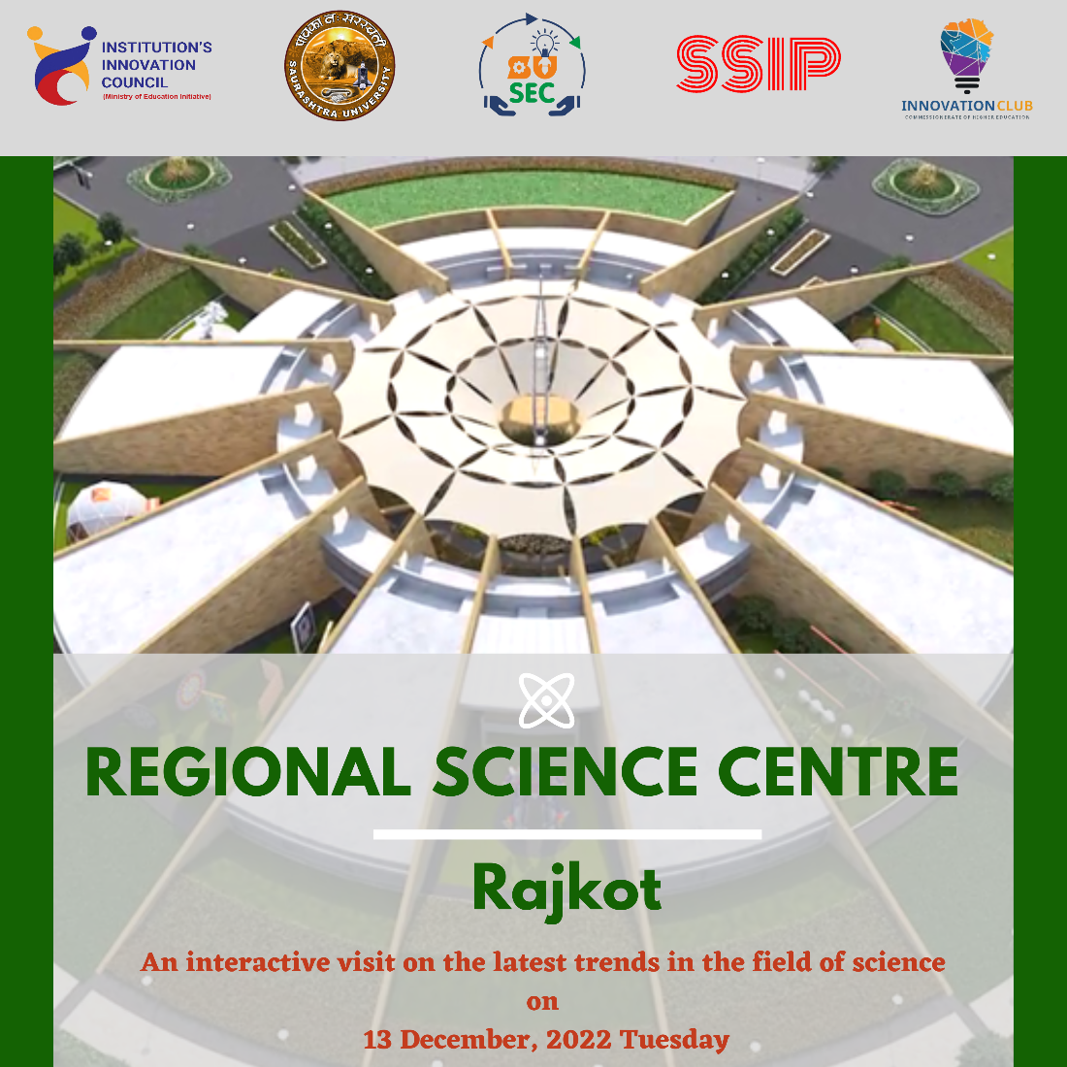

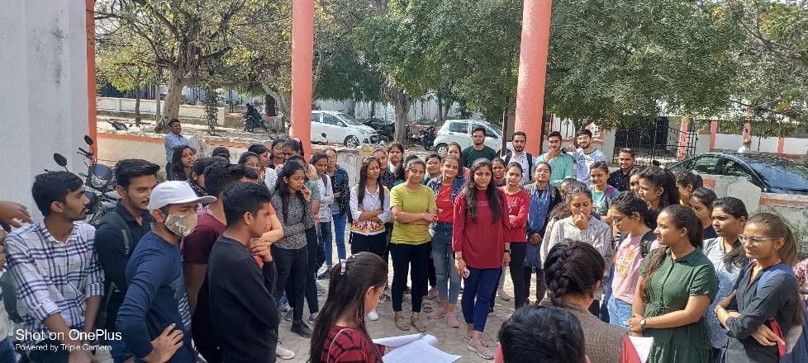
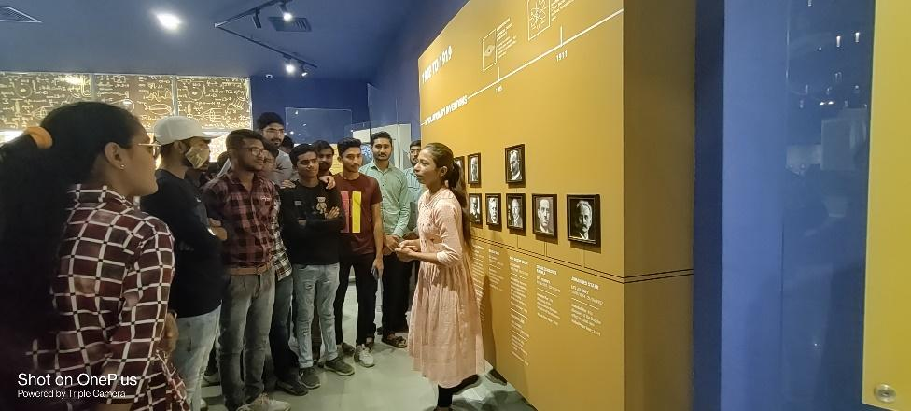
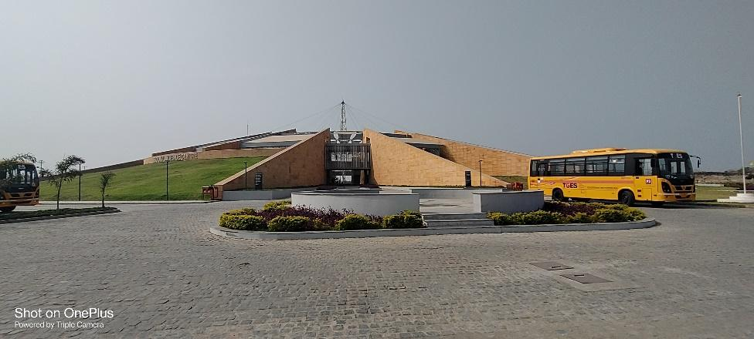
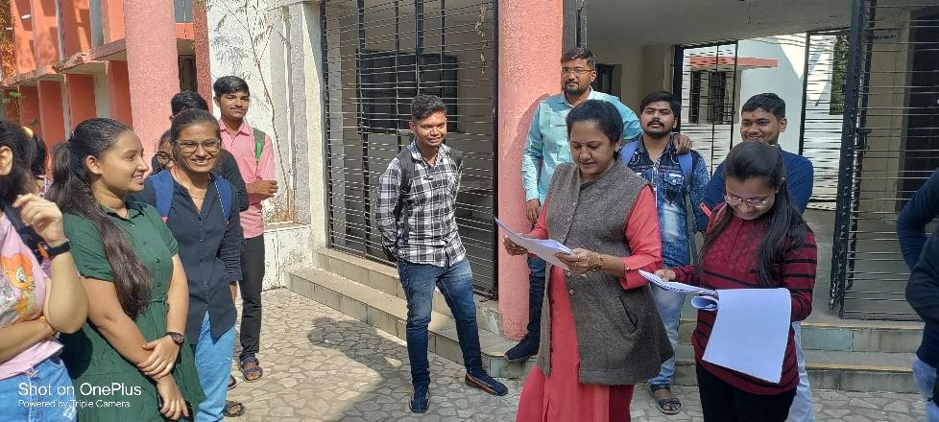

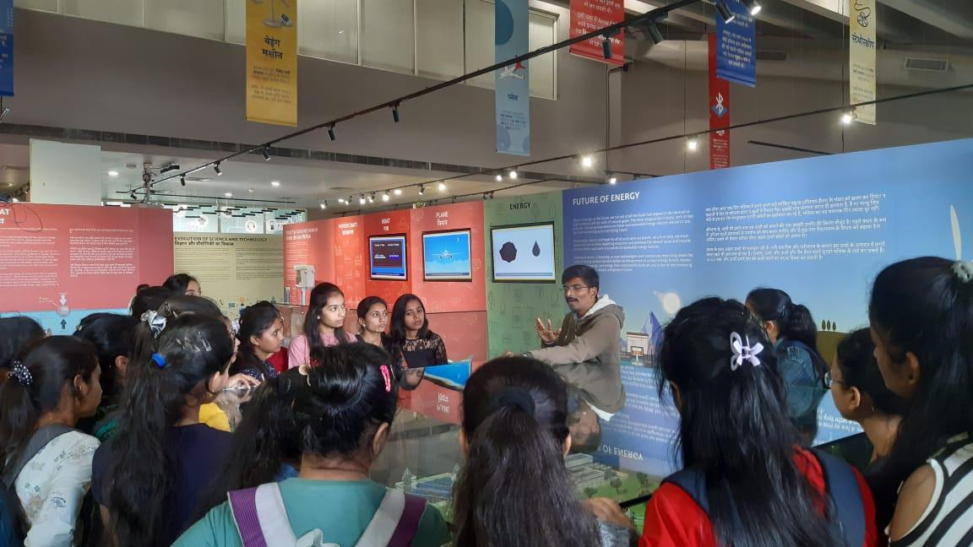
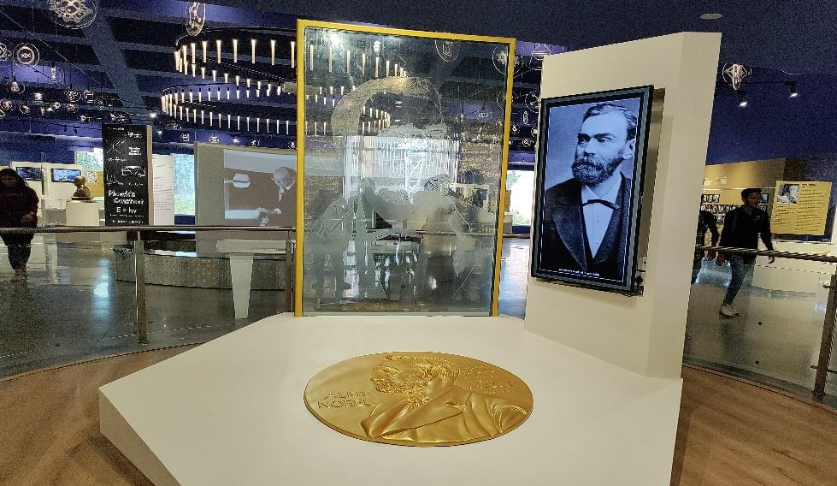
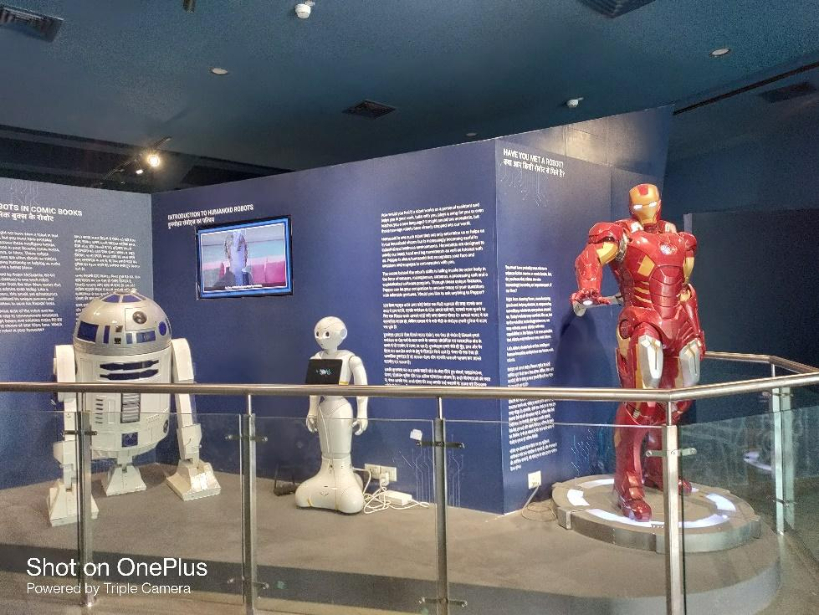

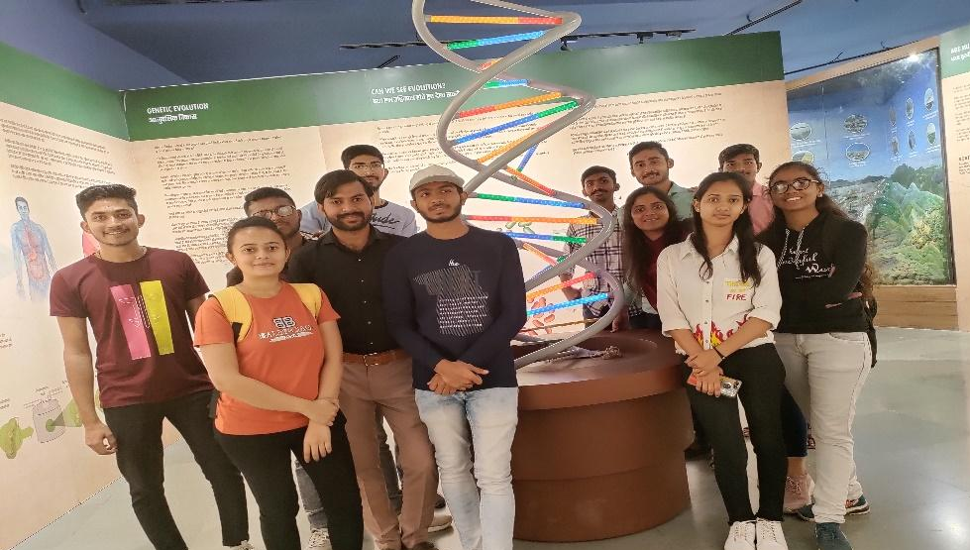
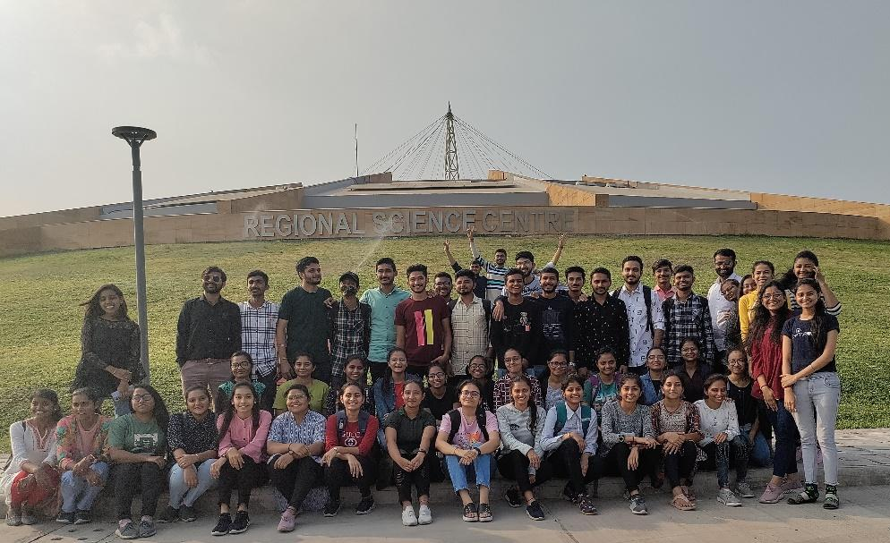

Connect Us:

https://www.linkedin.com/company/susec iic@sauuni.ac.in
https://www.facebook.com/iicsauuni bit.ly/SU-SSIP Location
https://www.instagram.com/susecrajkot https://bit.ly/SUSEC-youtube

